REVIEW OF 2021
CELEBRATING THE RE-OPENING OF CLASSICAL MUSIC COMPETITIONS
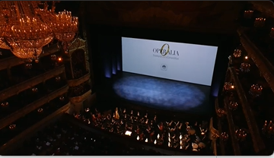
Operalia, The World Opera Competition took place on the stage of the legendary Bolshoi Theatre. This annual event is one of the most important of the classical music world and should not be missed.

